GIT Handson

1. Git Version check



1. Creation of developerA repository 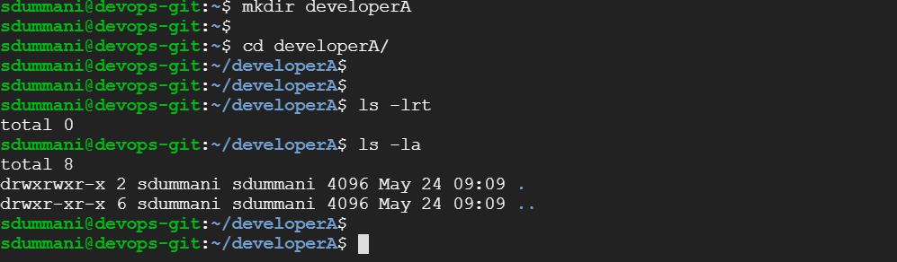
2. Git initialization

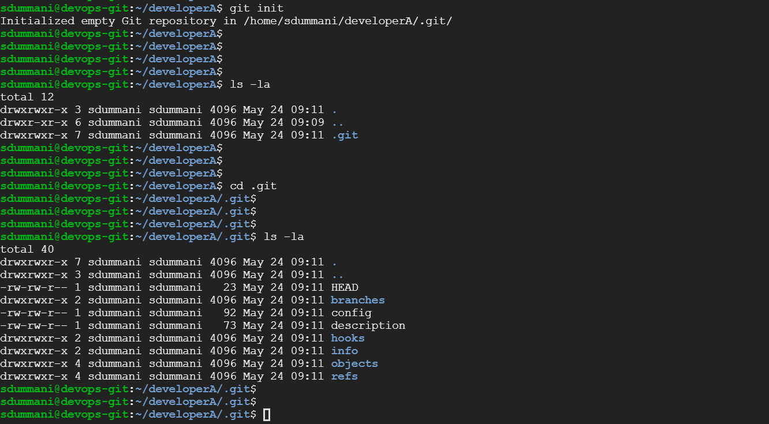

1. Creation of three files in Local Repo (DeveloperA)

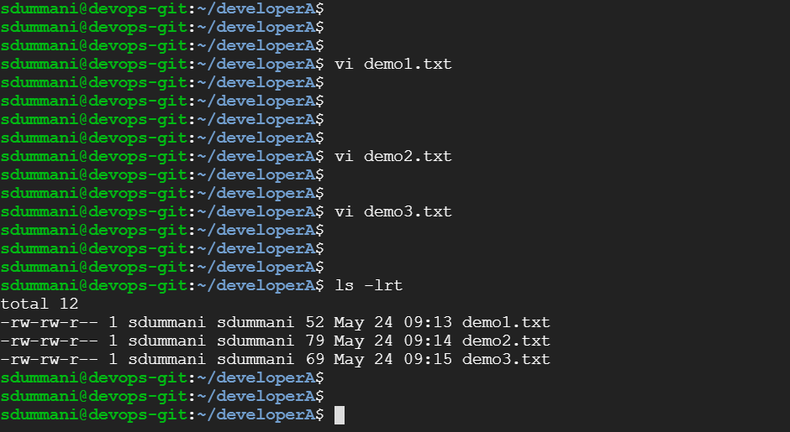

1. Git Status before adding to staging area 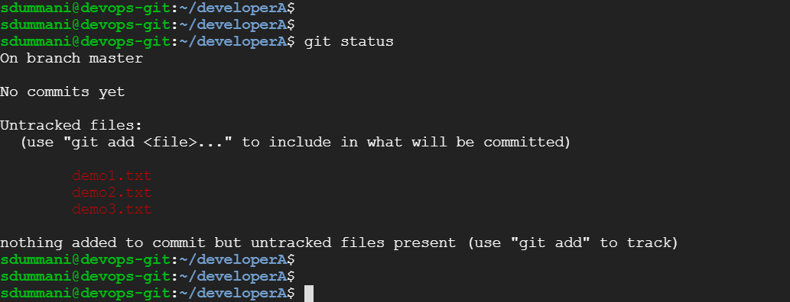
2. Adding to Staging Area

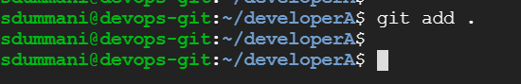

1. Git status after adding to Staging Area 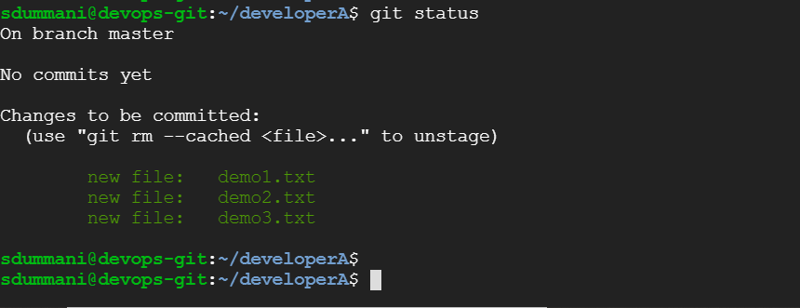
2. Adding configurations before Commit to Local Repo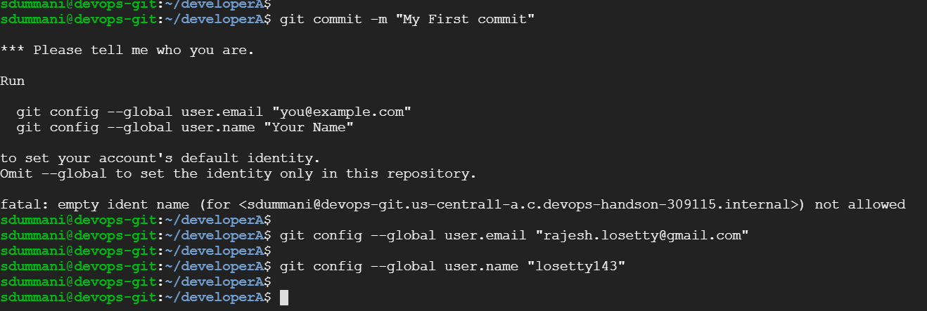
3. Committing to Local Repo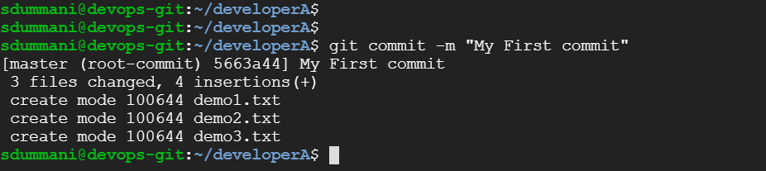
4. Create Remote Repository 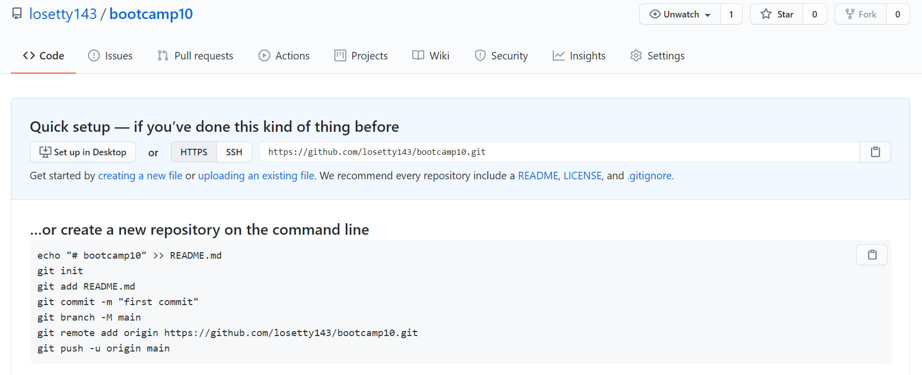
5. Adding remote repository to Local Repo



1. Display remote repos 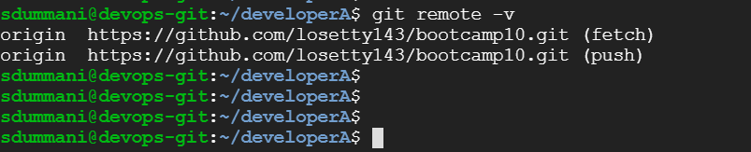
2. Making changes to files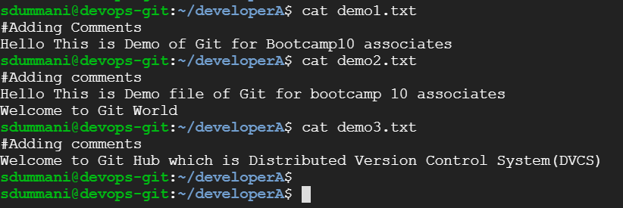

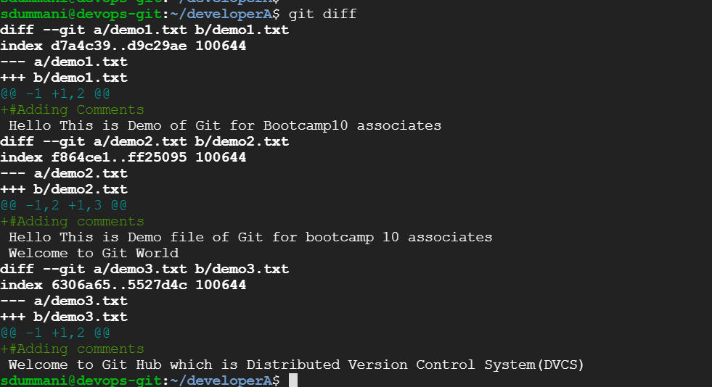

1. Committing the changes to Repo

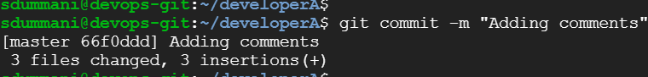

1. Pushing changes to Remote Repo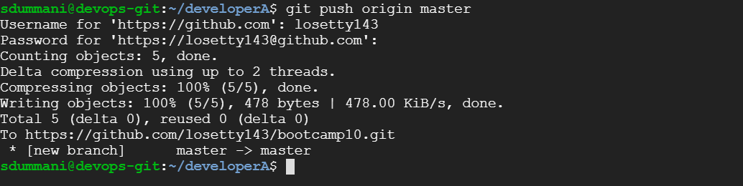

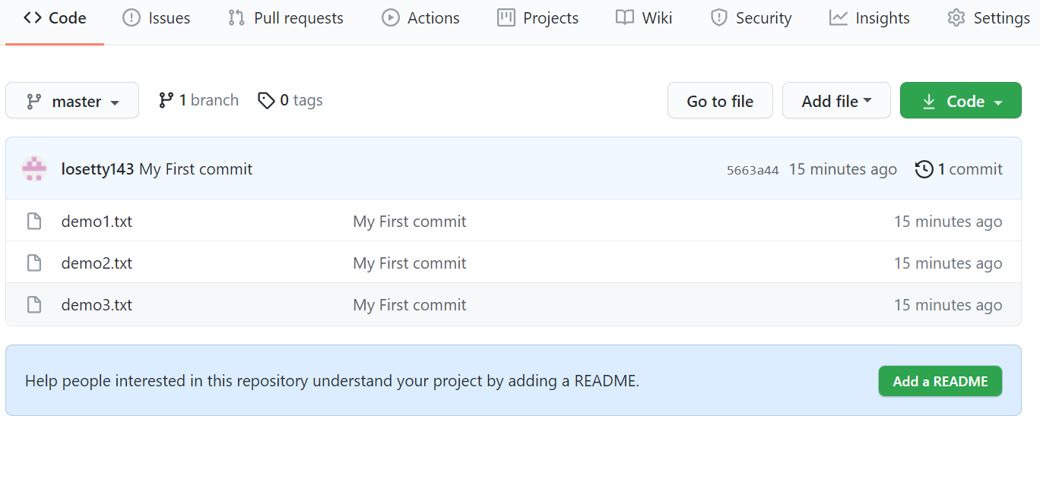

1. Creation of Anther Repo (Locally) Developer B



1. Cloning the repo to new local repo (Developer B)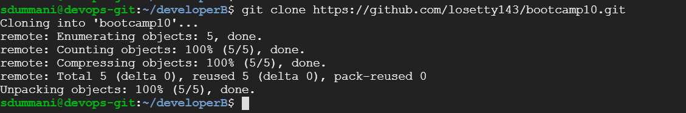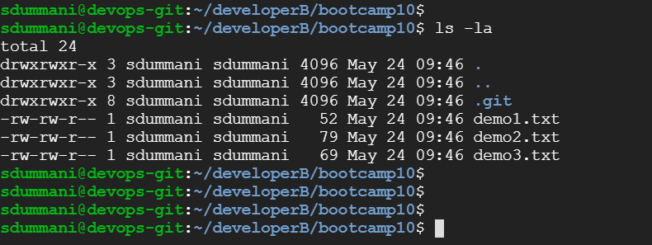

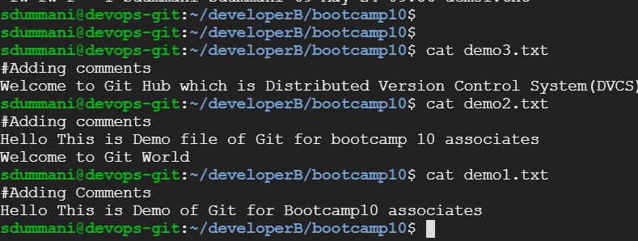

1. Changes from Developer B repository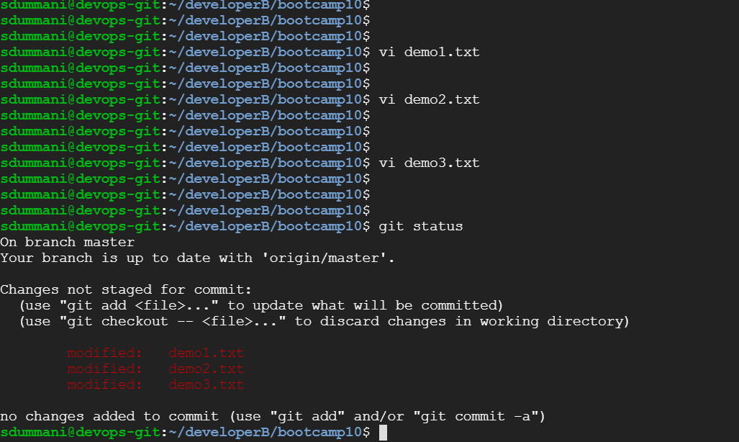
2. Adding changes to staging and commit those changes and pushing to remote repository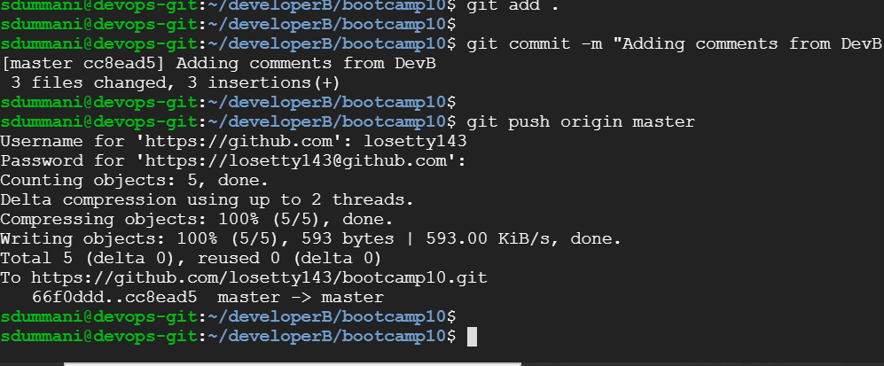
3. Synchronize changes in Dev A repo with DevB repo changes

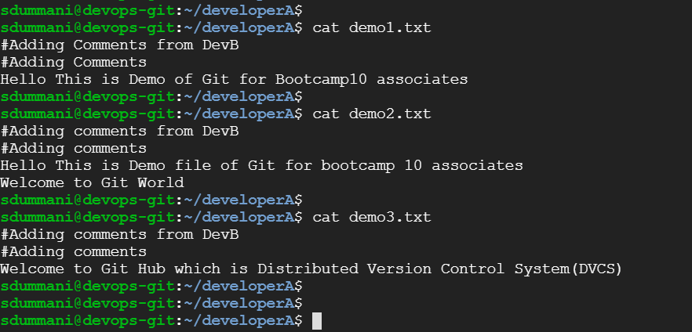

1. New Branch creation and checkout the new branch 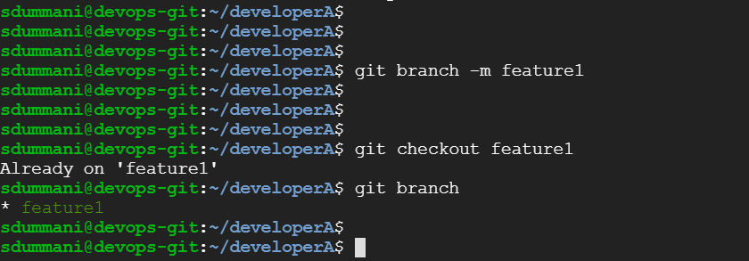
2. Changes to files from feature1 branch

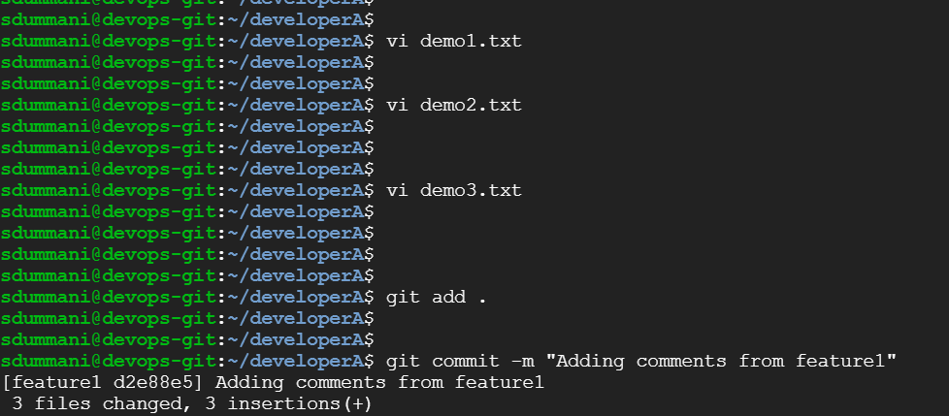

1. Merging feature and master branches 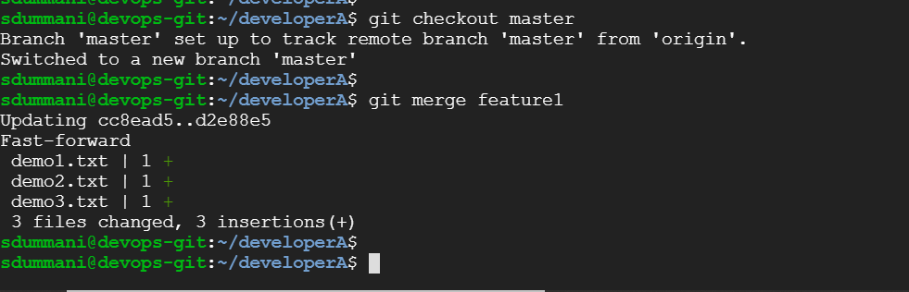
2. Pushing all the changes including feature1 changes to remote Repo